Level 5 | Unit: 21 | Emerging Technologies
Atakhanov Abdulhodiy

Level 5 | Unit: 21 | Emerging Technologies
Assessor: Konstantin Drygin
Group ID: 23-301 Data Analytics
Student ID: 230755
Submission Date: 05.06.2026

BTEC LEARNER ASSESSMENT SUBMISSION AND DECLARATION
When submitting evidence for assessment, each learner must sign a declaration confirming that the work is their own.
Learner (Student) ID: | 230755
Assessor Name: | Konstantin Drygin
BTEC Programme Title: | Pearson BTEC Higher Nationals in Information Technologies
Unit or Component Number and Title: | Unit 21: Emerging Technologies
Assignment Title: | Emerging Technologies: Impact, Adoption and Local Context in Uzbekistan
Date Assignments Submitted: | 05.06.2026

Please list the evidence submitted for each task. Indicate the page numbers where the evidence can be found or describe the nature of the evidence (e.g, graph, illustration).
Assignment Task Reference | Evidence Submitted | Page

Learner Declaration

I certify that the work submitted for this assignment is my own. I have clearly referenced any sources used in the work. I understand that false declaration is a form of malpractice.

Learner signature: Date: 05.06.2026


Table of Contents
Task – 1: Introduction. 4
Task – 2: Technology Overview. 5
Task – 3: Economic Factors. 6
Task – 4: Technology Connections. 7
Task – 5: Political and Social Factors. 9
Task – 6: Conclusion – Future Impact. 13
Task – 7: Presentation. 13
Reference List 14

Task – 1: Introduction.
An emerging technology is defined as a new, innovative solution that experiences fast growth and creates a high impact across various industries. It fundamentally changes traditional business models and daily human life. Digital wallet technology perfectly fits this description. It is rapidly growing because it replaces physical cash and plastic cards with secure, instant mobile applications. Modern digital wallets rely on advanced technical features like tokenization and API gateways to safely link users to banking networks. In Uzbekistan, this technology is delivering a high impact by aligning with the "Digital Uzbekistan — 2030" strategy. It drives cashless adoption and expands financial accessibility for citizens. This makes it a vital emerging technology for the country's future IT sector.

Task – 2: Technology Overview.
Introduction.
Forgetting a physical wallet at home or waiting in long bank lines is a very common and frustrating daily problem. Digital wallet technology solves this issue by allowing users to store their money and manage all financial transactions securely through their mobile phones.
Body 1: Technology Mechanism
Digital wallets operate by converting sensitive card data into secure tokens and processing transactions through an API gateway.
Argument 1.1: When a user adds a payment card, the system replaces the actual card number with an encrypted token stored in a secure database.
Argument 1.2: Every payment request passes through a secure firewall and an API gateway to ensure unauthorized users cannot access the system.
Argument 1.3: In Uzbekistan, this system connects directly with national payment infrastructure like UzCard and Humo for real-time processing.
Body 2: Application Today
This technology is widely implemented today in retail shops, e-commerce platforms, and public transport systems.
Argument 2.1: Millions of people in Uzbekistan use local platforms like Click, Payme and Uzum Bank every day to pay bills and transfer money.
Argument 2.2: Large online shopping platforms like Uzum Market have fully integrated digital wallets for a seamless checkout experience.
Argument 2.3: Furthermore, public transport users in Tashkent regularly pay for bus and metro rides using the ATTO digital wallet system.
Body 3: Evaluation
While digital wallets offer incredible speed and convenience, they also face serious cybersecurity threats and infrastructure challenges.
Argument 3.1: The main advantage is that users save time by completing transfers and utility payments in a few seconds without visiting a bank.
Argument 3.2: However, a significant problem is the risk of phishing attacks, fake mobile applications and data leaks that target user credentials.
Argument 3.3: Additionally, poor internet connectivity in remote regions of the country can limit the availability of digital payment services.
Conclusion
To conclude, digital wallets provide a high-speed payment method using microservices and national integrations, though security risks require close attention. In the next 5 to 10 years, this technology will likely integrate with artificial intelligence for automated fraud detection and support the national digital currency (CBDC).

Task – 3: Economic Factors.
Origin and Time to Market: Digital wallet technology began in the late 1990s with international companies like PayPal. There was a significant time delay between the initial idea and real business adoption because early mobile networks were weak and smartphones did not exist. Mass market use only started after 2010 with the rise of Apple Pay and Alipay. In Uzbekistan, Click introduced SMS-banking in 2011, but the real economic boom happened after 2018 when affordable smartphones and mobile internet became available across the country.
Business Model and Monetization: Digital wallets mainly generate revenue through a transaction-based (pay-per-use) and platform business model. Companies charge a small interchange fee, usually between 0.5% and 1.5%, on peer-to-peer (P2P) transfers and merchant payments. They also create value by charging businesses for accessing payment API gateways. A standard subscription model does not work in this industry because customers expect basic wallet services to be free. For example, the local company Payme provides free wallet applications to individuals but charges commercial merchants for processing payments.
Market Size and Customers: The digital payments market in Uzbekistan is growing rapidly due to the expansion of e-commerce. According to official reports, digital transactions increased by over 40% in recent years. The ecosystem serves three types of customers: individuals (B2C), business merchants (B2B) and government platforms (G2C). The B2B sector pays the most revenue because commercial merchants process large volumes of daily sales and pay processing fees to increase their customer reach.
Costs and Profit: The main expenses for a digital wallet include software development, secure cloud infrastructure, marketing and live support. The biggest cost is building and maintaining secure servers and databases to prevent data leaks. To achieve profitability, a wallet provider must balance its Customer Acquisition Cost (CAC) and the Average Revenue Per User (ARPU). Major local applications like Click and Payme are highly profitable because their long-term user revenue easily covers the initial acquisition costs.
ROI and Scalability: The Return on Investment (ROI) is long-term, usually taking 3 to 5 years because initial infrastructure setup costs are high. However, the technology has excellent scalability. When a system grows from ten thousand to two million users, the infrastructure cost per user drops significantly. System performance remains stable because the core wallet engine uses microservices and advanced caching tools to handle high tranzaction traffic.
Risks, Competition and Market Impact: The primary risks are technical downtime, system errors and cyber-security threats. Competition is very intense and market entry barriers are high because new startups need a formal Central Bank license and high initial capital. Traditional cash handling services lose profits, while modern digital ecosystems win market share. This economic dynamic connects directly to Task 4, where the wallet engine must maintain robust technical connections with multiple external payment networks and databases.
Regulation and Local Market: The Uzbek government strongly supports this technology through the national law "On Payments and Payment Systems" and the "Digital Uzbekistan — 2030" strategy. Local market challenges include low digital literacy in rural regions and infrastructural electricity gaps. Despite this, the full integration of UzCard and Humo networks proves that digital wallets are highly realistic and successful today. This links to Task 5, where government regulations directly influence social trust and public user behavior.

Task – 4: Technology Connections.
Digital wallet technology does not work in isolation; it operates within a complex ecosystem of past, present, and future technologies. Understanding these connections helps to see how the system processes daily transactions and where it is moving next.
What it Replaces and Inherits From: Digital wallets inherit basic financial principles from traditional core banking systems and relational SQL databases. However, they actively replace obsolete physical technologies. Instead of using old Magnetic Stripe Cards, Dial-up POS Terminals and Paper Receipts users now complete transactions electronically. This shift reduces physical maintenance costs and speeds up checkout times at cash registries.
What it Depends On: The core wallet engine heavily depends on mature infrastructure for security and communication. It requires robust Network Firewalls to protect user data and an SMS Gateway to send transaction alerts. For daily operations, the emerging wallet application depends on a Microservices Architecture to handle high user traffic without crashing. In Uzbekistan, it absolutely relies on national networks like UzCard and Humo to move money between accounts, and the government OneID Platform to verify user identities legally.
Future Convergence: In the coming years, digital wallets will merge with future technologies to solve current limitations. They will integrate with AI Fraud Detection to automatically block fake accounts and stop phishing. Furthermore, they will adopt Blockchain Ledgers and connect with the Central Bank Digital Currency (CBDC), also known as the Digital Som, to allow direct peer-to-peer payments without traditional bank intermediaries.
Technology Interconnection Diagram
Below is the structured Mermaid diagram representing the 36 key technology blocks divided into four distinct maturity levels, using clear relationship labels as required by the roadmap.
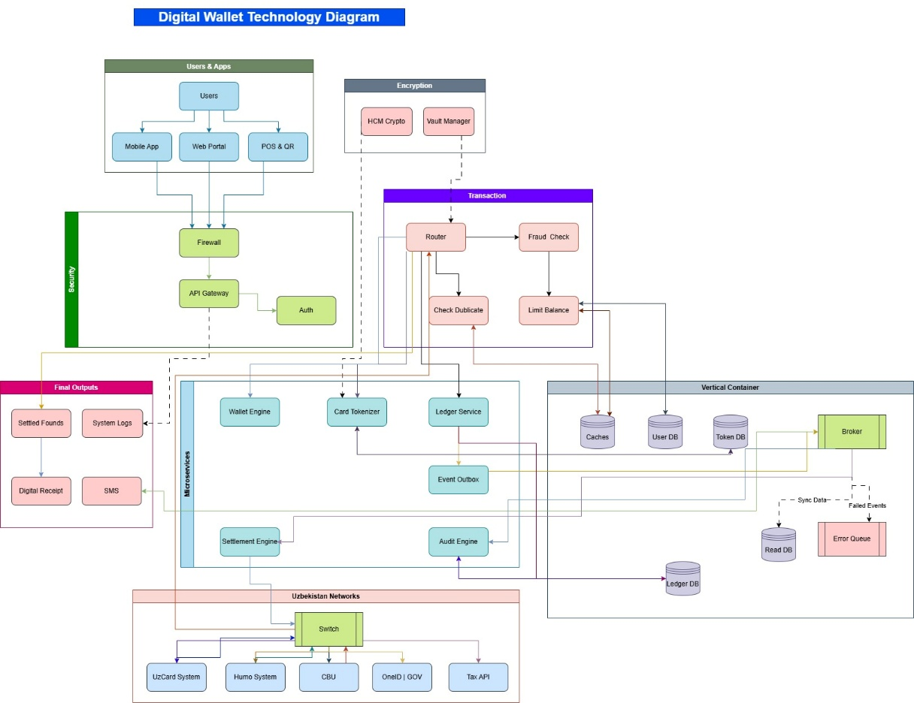

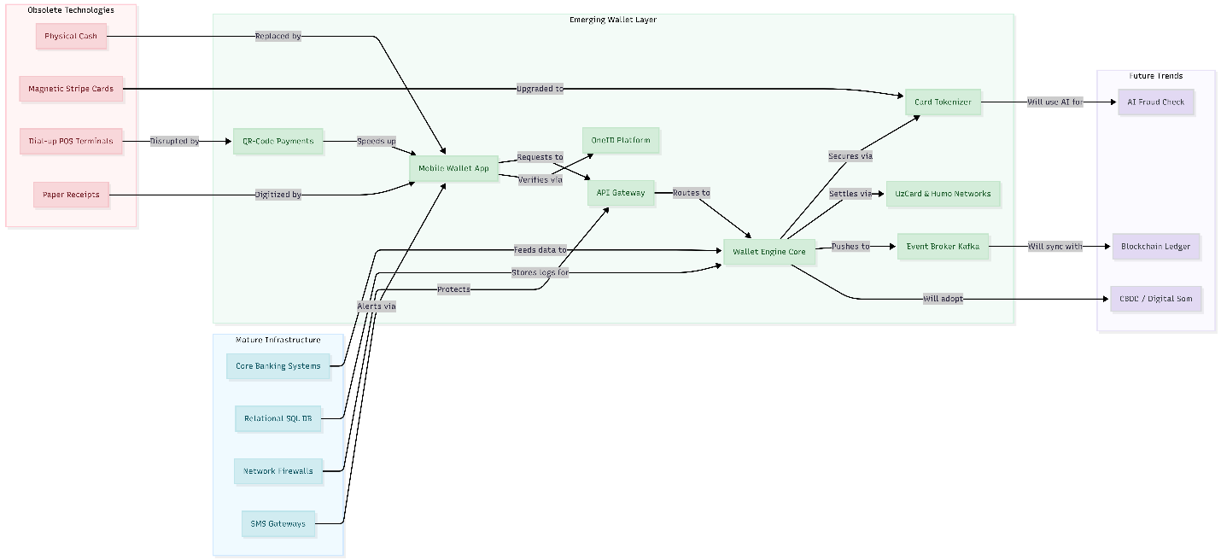

Task – 5: Political and Social Factors.
Introduction
Implementing an emerging technology like digital wallets depends heavily on external political and social factors. The external environment can either accelerate public adoption or create strict operational barriers for companies. Based on the provided "Digital Wallet Political and Social Factors" diagram, these external pressures directly shape how financial technology serves local citizens and businesses.
Political and Regulatory Factors
Political factors play a major role in establishing trust and safety for digital financial systems. In Uzbekistan, the government actively promotes a cashless economy through the "Digital Uzbekistan — 2030" strategy. This framework provides official political backing for modernizing the country's financial infrastructure. Additionally, Central Bank regulations create a strict licensing environment that protects the local ecosystem from unstable or fraudulent financial startups.
To ensure overall system security, wallet operators must follow national Data Protection Laws and strict Cyber Security Standards. These legal rules force companies to secure their core networks and prevent sensitive user information from leaking. A real-world local example is the mandatory integration with the government's OneID platform. This integration legally verifies the identity of every wallet user, which significantly reduces financial crimes and online fraud across the entire network.
Social and Cultural Factors
Social factors directly determine how fast everyday citizens accept digital payment methods instead of using physical cash. The primary social impact of digital wallets is increasing financial accessibility and digital inclusion across the population. Previously, people living in remote regions of Uzbekistan had limited access to physical bank branches to manage their money. Today, mobile wallet platforms give them immediate access to secure payment services, which improves daily convenience and builds public trust.
As users become more comfortable with mobile applications, cashless adoption rises significantly across society. This cultural shift creates a smoother environment for simple online businesses and speeds up daily market transactions. However, there are also systemic social challenges that companies must address. Many citizens still worry about privacy concerns and data leak risks when using mobile apps.
Furthermore, the rapid growth of digital transaction engines triggers major employment changes and job automation. For instance, as automated digital billing systems expand, traditional bank tellers and cashiers see reduced demand for their manual work. These workers must learn new digital skills to stay employed in the modern job market.
Ecosystem Stakeholders and National Impact
The social and political environment closely connects multiple ecosystem stakeholders. Traditional banks must collaborate with fast-growing platforms like the Payme and Click ecosystems to provide stable, modern financial products. When these systems work together, they serve and empower local businesses, retail merchants and ordinary citizens. Ultimately, these combined social and political adjustments lower transaction costs, boost e-commerce growth and drive national digital transformation across Uzbekistan.
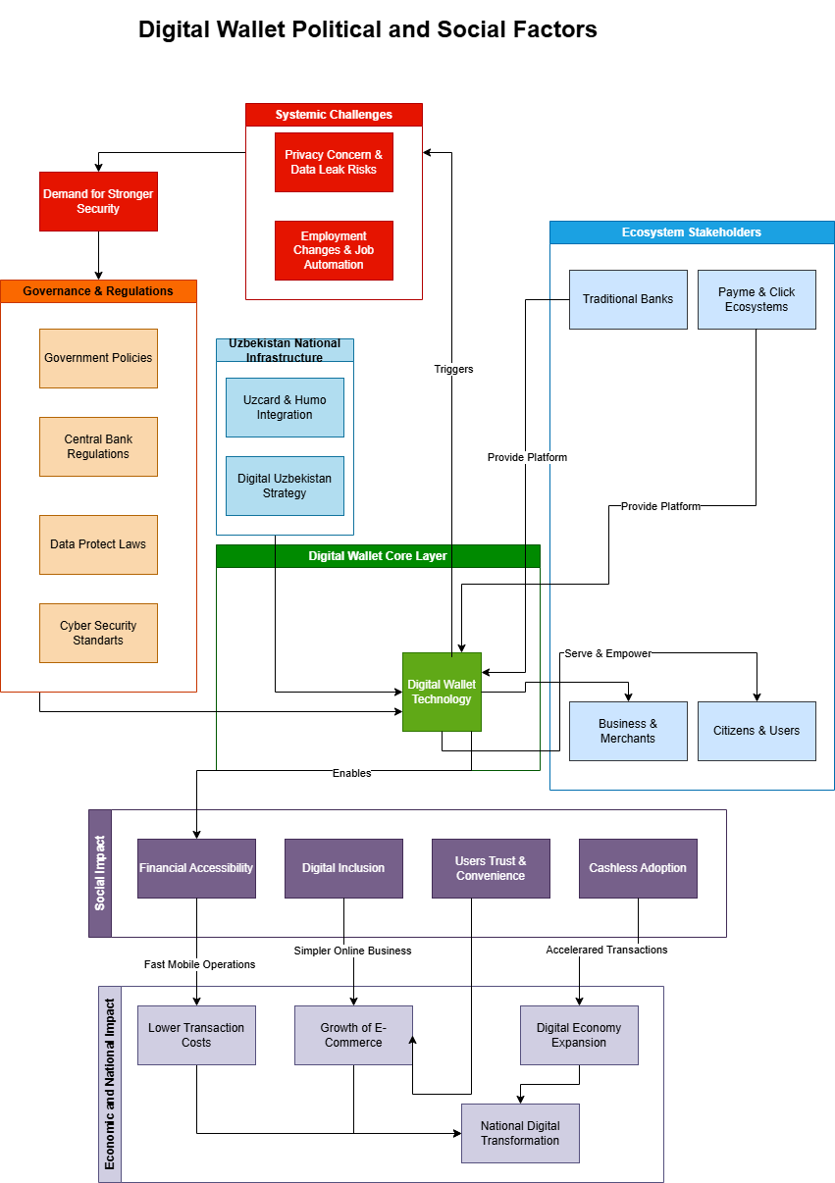
PEST Analysis Summary Table
The table below rates the external factors affecting digital wallets in Uzbekistan based on the Appendix E evaluation method. The total sum of all factor weights equals exactly 1.00.
Category / Factor | Weight (A) | Strength (B) | Score (A×B) | Type | Local Context / Comment
Political
1. "Digital Uzbekistan — 2030" | 0.15 | 5.0 | 0.75 | + | Strong State Support For Digital Transition.
2. Central Bank Rules & Oneid | 0.15 | 4.0 | 0.60 | + | Mandatory Identity Checks To Stop Fraud.
Economic
3. E-Commerce Growth | 0.15 | 4.5 | 0.675 | + | Uzum Market Increases Online Wallet Demand.
Social
4. Digital Inclusion | 0.15 | 4.0 | 0.60 | + | Easy Mobile Banking For Rural Population.
5. Job Automation | 0.10 | 3.0 | 0.30 | - | Fewer Traditional Bank Cashiers Needed.
Technological
6. Uzcard & Humo Networks | 0.15 | 5.0 | 0.75 | + | Reliable National Payment Infrastructure.
7. Data Leak Risks | 0.10 | 4.0 | 0.40 | - | Cyber Threats Reduce Public User Trust.
Total | 1.00 |  | 4.075 |  | External Environment Strongly Favors The Technology.

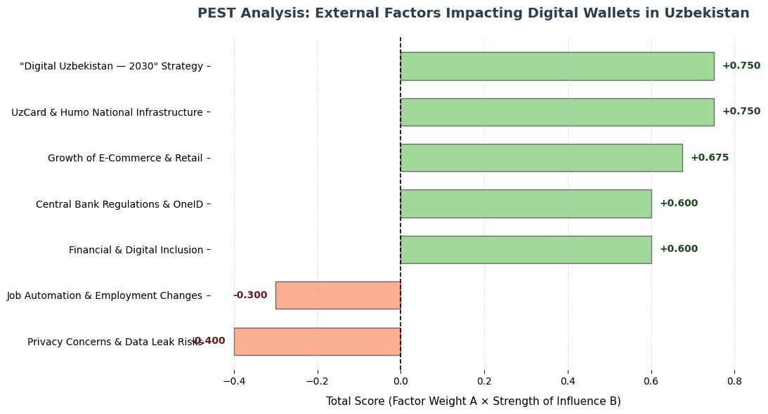
Interpretation of PEST Results
Factors Needing Constant Monitoring: The "Digital Uzbekistan — 2030" strategy (0.75) and the UzCard/Humo infrastructure integration (0.75) score the highest. This means wallet providers must constantly align their software updates with national infrastructure changes and government programs.
Opportunities to Use Now: Companies can exploit the rapid growth of e-commerce and the high demand for financial inclusion. Offering simple payment APIs to local online businesses can capture a large market share very quickly.
Risks to Fix First: Privacy concerns and data leak risks (0.40) are serious social barriers. Wallet creators must invest heavily in advanced tokenization and clearer security interfaces to make users feel safe spending their money digitally.

Task – 6: Conclusion – Future Impact.
In my opinion, digital wallet technology will continue to grow rapidly in Uzbekistan and will definitely not fail. The main argument for its long-term success is the massive demand from our young population and the continuous support from state digital programs. Moving money through a smartphone is simply much more convenient and faster than carrying physical cash or plastic cards.
However, significant risks still exist, such as sophisticated phishing scams, data leak threats and unexpected system downtimes that can hurt user trust. To overcome these serious challenges, local wallet providers must adapt by adopting future innovations like AI fraud check systems. They also need to prepare for integration with the upcoming Central Bank Digital Currency (CBDC). Overall, I highly believe that digital wallets will completely transform our financial sector and lead Uzbekistan into a truly cashless society.

Task – 7: Presentation.
Link: https://docs.google.com/presentation/d/1oo7XtGuPbFh0JVnF5z2RCqasxPiwyXdZEJ2Ls11vcdk/edit?usp=sharing

Reference List
- Central Bank of the Republic of Uzbekistan (2025) Review of the Payment Systems Market in the Republic of Uzbekistan. Tashkent: CBU. Available at: https://cbu.uz (Accessed: 15 May 2026).
- Christensen, C. M. (2015) The Innovator's Dilemma: When New Technologies Cause Great Firms to Fail. Boston: Harvard Business Review Press.
- Republic of Uzbekistan (2019) Law of the Republic of Uzbekistan "On Payments and Payment Systems", No. LRU-578. Tashkent: LexUZ Legal Database. Available at: https://lex.uz/docs/4574903 (Accessed: 20 May 2026).
- Republic of Uzbekistan (2020) Decree of the President of the Republic of Uzbekistan "On Approval of the Strategy 'Digital Uzbekistan — 2030' and Measures for its Effective Implementation", No. PD-6079. Tashkent: LexUZ Legal Database. Available at: https://lex.uz/docs/5032121 (Accessed: 20 May 2026).
- Schwab, K. (2016) The Fourth Industrial Revolution. Geneva: World Economic Forum.
- Wallet, Digital. “Digital Wallet Slide Deck.” Google Docs, 2019, docs.google.com/presentation/d/1oo7XtGuPbFh0JVnF5z2RCqasxPiwyXdZEJ2Ls11vcdk/edit?usp=sharing. Accessed 31 May 2026.

